**Issue:** Complete Order in QSOTS

**Resolution:**

Below are the steps to complete the order in QSOTS.

1. Search activity_id from acty_by_so view in Arthur.

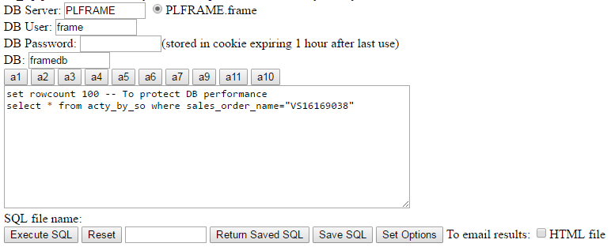

1. Query activity table with this activity_id.

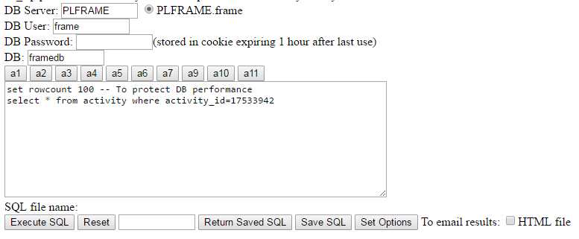

1. Update the activity_status,bill_status, turn_up_completion_date_time , turn_up_load_type in activity_table. Below is the update query:

Update activity SET activity_status = 3, turn_up_completion_date_time ="Apr 29 2011 12:00AM", turn_up_load_type = 'M', bill_status = 3 WHERE activity_id in (12629349,12629350)

**NOTE:** turn_up_completion_date_time is the present date and time.